Coursera inference : probability 2

* Random variable : Numerical output of an experiment ( Note that it is NOT the probability value) Example: measuring the height of adults around the word would be **continuous.**
* PMF gives the **probability** that a discrete variable is exactly equals to some value. For example roll a die , the probability of outcome is one is ?
* PDF -> note on notebook
* Survivor function S(x) is the compliment of the CDF F(x), function of x equals to the **probability** that the **random variable X** greater than the value x.
* Example: given CDF: F(x)=(x^2)/4, what is the 50th percentile ?

0.5=(x^2)/4 , x^2=2 , it’s the probability of the point F(x) take a value 1/2

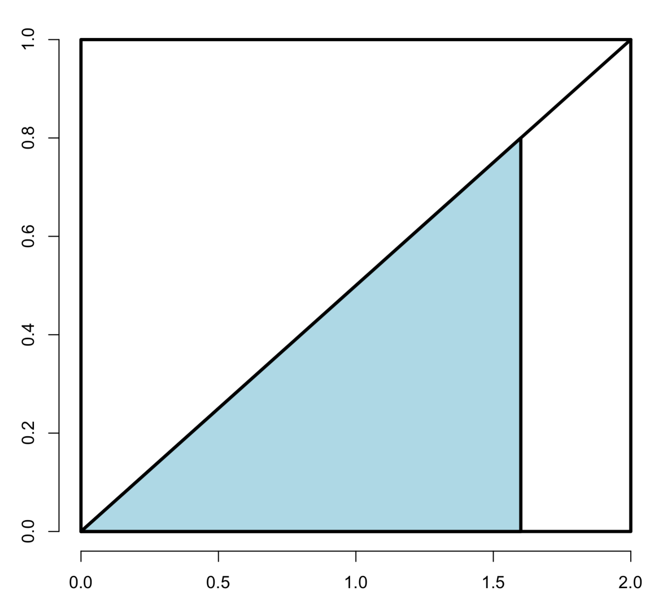

CDF=sqrt(2) means half of it falls to the left of 1.41.

* A probability model **connects data to a population** using assumptions.

* Conditional probability P(A|B) , probability of event A , given that B has occurred. P(A|B)=P(A & B)/P(B)
* Example , rolling a die, A is probability of rolling a 3, and B is probability of rolling a odd. P(A & B)= ? (Not 1/6 * 1/3) , since A is a subset of B, the probability of P(A & B) is actually P(A).
* Bayes’s rule: P(A|B)=P(A & B)/P(B) = P(B|A)P(A)/P(B) ( **P(A|B)P(B)=P(B|A)P(A)=P(A&B)** , Suppose we don’t known P(B), but we know it’s conditional probability P(B|A) and P(B|~A), then P(B)=P(B|A)P(A)+P(B|~A)P(~A)=P(A&B)+P(~A&B)=P(B)
* We want to estimate P(B|A), we don’t know P(A) but we know P(A|B) and P(A|~B) , how can we resolve P(B|A)? => since P(B|A)=P(A|B)P(B)/P(A)=P(A|B)P(B)/(P(A|B)P(B)+P(A|~B)P(~B))